1). Use the Customer Product relational database in file ‘Inlab_UDF.sql’ to attempt the questions below.

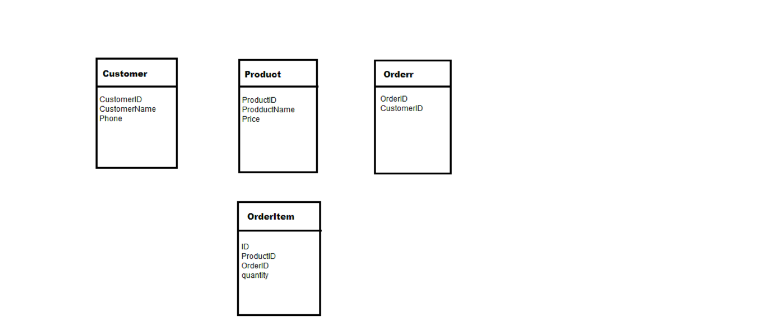

* 1. Write a scalar UDF that calculates the total sale(money) of a certain product.
  2. Write an inline UDF that lists the information of all the ordered products by a specific user, the user id is passed as input parameter.
  3. Write a procedure which displays productID, productName of all products along with total sale of that product.

(Hint: use function created in 1.1).